 | Course Name: Design Patterns/Thinking LAB | EXPERIMENT NO. 10
 | Course Code: 20CP210P  Faculty: Dr. Payal Chaudhari | Branch: CSE | Semester: IV
(To be filled by Student)
Submitted by: Meet Jain
Roll no: 23BCP093

Objective: To familiarize students with standard Structural design patterns.
Experiment: Explain the Decorator Design pattern and write a program using any object-oriented programming language to demonstrate the working of Decorator Design pattern.

Code:
interface Coffee {
double cost();
}

class SimpleCoffee implements Coffee {
public double cost() {
return 5.0;
}
}

class CoffeeDecorator implements Coffee {
Coffee coffee;

CoffeeDecorator(Coffee coffee) {
this.coffee = coffee;
}

public double cost() {
return coffee.cost();
}
}

class MilkDecorator extends CoffeeDecorator {
MilkDecorator(Coffee coffee) {
super(coffee);
}

public double cost() {
return coffee.cost() + 2.0;
}
}

class SugarDecorator extends CoffeeDecorator {
SugarDecorator(Coffee coffee) {
super(coffee);
}

public double cost() {
return coffee.cost() + 1.0;
}
}

public class Main {

public static void main(String[] args) {
Coffee coffee = new SimpleCoffee();
System.out.println("Plain Coffee: $" + coffee.cost());

coffee = new MilkDecorator(coffee);
System.out.println("Coffee with Milk: $" + coffee.cost());

coffee = new SugarDecorator(coffee);
System.out.println("Coffee with Milk & Sugar: $" + coffee.cost());
}
}

Output:

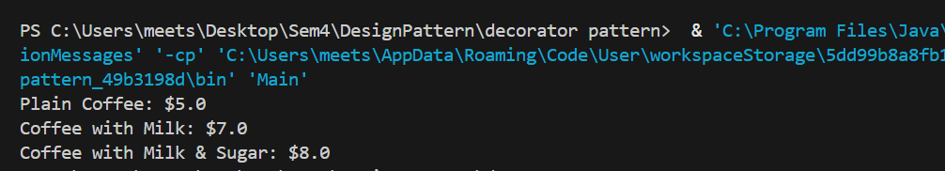

Class Diagram:

